(Approx. 630 words)

Customize Your Quick Access Toolbars in Office
By Nancy DeMarte, 2nd Vice President, Sarasota Technology Users Group, FL
May 2017 issue, Sarasota Monitor
www.thestug.org
ndemarte (at) verizon.net

Microsoft Office offers hundreds of tools on its extensive “ribbon” structure. A user can spend a long time trying to locate a specific tool. To relieve that frustration, Office added a Quick Access toolbar to some of its Office applications and recently to the File Explorer window.

Located in the upper left corner of the title bar above the ribbon tabs, the Quick Access toolbar is always visible, which makes it a handy place to store your favorite tools. It contains a few icons to get you started, such as Save, Undo, and Redo. You can, however, customize this area to include any tools you want. It isn’t difficult and can save you a lot of extra clicks. Using Word as an example, first open a document to reveal the Quick Access toolbar above the left end of the ribbon.

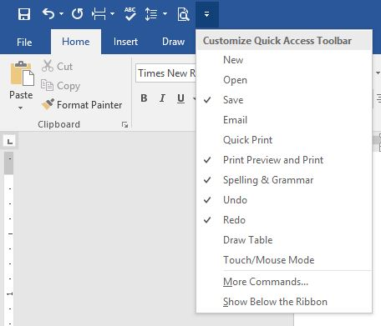
Then click the downward pointing triangle with a line over it at the right end of the Quick Access toolbar. This opens a menu of the most popular tools (commands). (Fig 1) Clicking an item puts a checkmark next to it, which adds it to Quick Access.
Figure 1 Quick Access dialogue box

To see more tools, click “More Commands.” This opens a large dialogue box (Fig 2) that contains all the tools and commands which are part of Office, such as Word, Excel, PowerPoint, and Outlook.

Take a careful look at this large box. In the list on the left side, Quick Access toolbar should be highlighted. If it isn’t, click to select it. In the center pane is an alphabetical, scrollable list called “Choose commands from” with “Popular Commands” displayed. If you don’t find the tool you’re looking for in the extensive Popular Commands list, you can click the down arrow next to Popular Commands and select the huge “All Commands” list. If you still have no success, try “Commands not found on the Ribbon,” which includes tools such as the Envelope and Label Wizard, AutoCorrect Sentence Caps, and Decrease Paragraph Spacing.

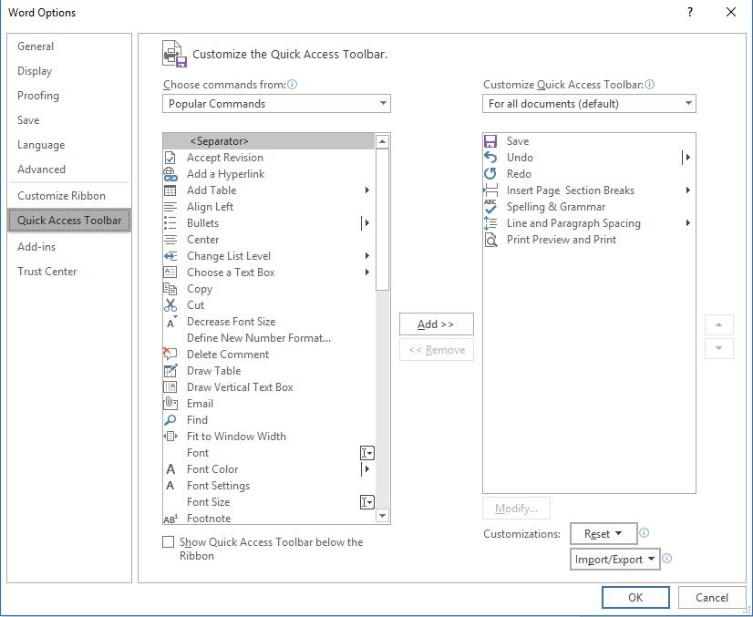
Figure 2 Full Quick Access customization dialogue box
To add a command to the Quick Access toolbar, click a tool in the left pane, then click “Add” between the panes, and the tool will appear in the right pane. Click OK to close the box. Notice that below “Add” is “Remove.” You can remove tools from the Quick Access bar by clicking a tool in the right pane and then Remove. In the bottom right corner of the dialogue box are two other options: “Reset” and “Import/Export.” Click Reset to return your Quick Access toolbar to its factory setting. Import/Export can put all your customized settings into a file to be exported to another computer using a thumb drive or other media.

Tips:
1. Make sure you add only tools you use regularly to Quick Access. You don’t want to clutter your window with another long line of icons above the Ribbon. Some of my favorites in Word are the Spelling and Grammar checker, Line and Paragraph spacing, and Print Preview and Print.
2. You can position the Quick Access bar below the ribbon instead of above. Click the arrow at the right end of the Quick access bar and select the last item, “Show below the Ribbon."
3. This same large dialogue box can be used to customize the Ribbon. Click “Customize Ribbon” in the list on the left directly above Quick Access Toolbar. You add or remove tabs and tools to make the Ribbon fit your needs.

Look for Quick Access toolbars or lists across many of the Microsoft applications. They can save you time and effort.

